**PROTECTING PEOPLE AND PLACES**

***Fifty years after the Health and Safety at Work Act 1974***

**Wednesday 17th April 2024**

**Day’s Suite, Swansea.com Stadium (**formally Liberty Stadium**), Swansea SA1 2FA**

***Declaration - I understand that the allocation of stands is the responsibility of the organisers and that I may not be able to secure the stand position(s) I have requested.***

**Confirmation of stand number will be made after full payment and return of completed booking form.**

|  |  |  |  |  |  |  |  |  |  |  |  |  |  |  |  |  |  |  |
| --- | --- | --- | --- | --- | --- | --- | --- | --- | --- | --- | --- | --- | --- | --- | --- | --- | --- | --- |
| **Organisation /**  **Company Name** | |  | | | | | | | | | | | | | | | | |
| **Address & Postcode** | |  | | | | | | | | | | | | | | | | |
| **Contact Name** | |  | | | | | | | | | | | | | | | | |
| **Signature** | |  | | | | | | | | | | | | | | | | |
| **Telephone**  **(landline + mobile)** | |  | | | | | | | | | | | | | | | | |
| **Your e-Mail address** | |  | | | | | | | | | | | | | | | | |
| **Company e-Mail address** | |  | | | | | | | | | | | | | | | | |
| **Preferred Exhibition Stand No?** *(See floor plan for details.)* | | | 1st  Choice | | |  | | | 2nd  Choice |  | | | 3rd  Choice | | |  | | |
| **Is a power socket supply required?** | | | | | | | | | | | | Yes | |  | No | | |  |
| **Is a trestle table required?** | | | | | | | | | | | | Yes | |  | No | | |  |
| **Name and Tel No: of Persons staffing the stand** | | | | 1. | | | | | | | Tel No: | | | | | | | |
| 2. | | | | | | | Tel No: | | | | | | | |
| BACS Payment for the sum of £300  ***(SWSGA is not registered for VAT).*** | | | | | BACS payments to be made to ‘South Wales Safety Groups Alliance’ Bank **NatWest**, Sort Code **55-61-50**, Account No. **73679836. Please quote your business name as the reference.** BACS payment made on _____________ (date). | | | | | | | | | | | | | |
| Purchase Order No:  *(If an invoice is required)* | | | | |  | | | | | | | | | | | | | |
| ***Please indicate below if you are interested in sponsoring items for the Conference.*** | | | | | | | | | | | | | | | | | | |
| £400 - Podium | | | | | | |  | £400 - Audio Visual Equipment | | | | | | | | |  | |
| £400 - Stage | | | | | | |  | £200 - Prize Draw | | | | | | | | |  | |
| Other (please specify) |  | | | | | | | | | | | | | | | | | |
|  | | | | | | | | | | | | | | | | | | |

*Please return your completed booking form to:* [south.wales.sga@gmail.com](mailto:south.wales.sga@gmail.com) *Any questions relating to your stand booking, please contact Steve Bergiers at:* [south.wales.sga@gmail.com](mailto:south.wales.sga@gmail.com)

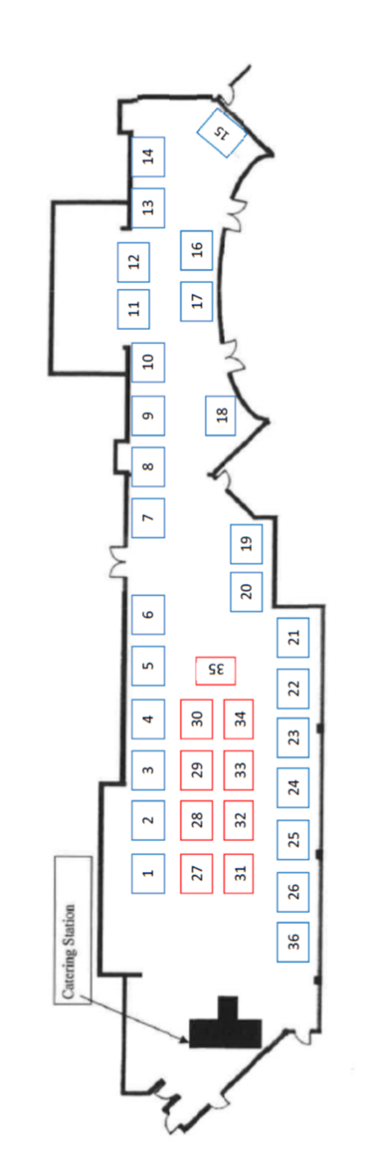

**Exhibition Hall Plan View of the Day’s Suite, Level 2 Swansea.com Stadium (**formally Liberty Stadium**)**



**Stands marked as blue are available with electrical provision, those marked as red have no power provision.**