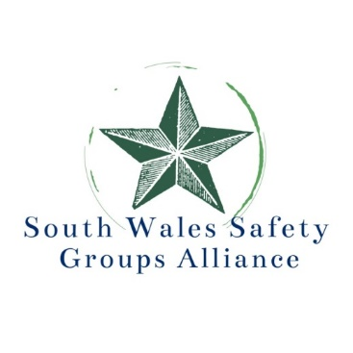

Annual Conference & Exhibition

PROTECTING PEOPLE AND PLACES
Fifty years after the Health and Safety at Work Act 1974

Wednesday 17th April 2024
Day’s Suite, Swansea.com Stadium (formally Liberty Stadium), Swansea SA1 2FA

As we all know, understanding the past shapes the future. And this conference will be a celebration of the Health and Safety at Work Act 1974 Fifty years ago. It begins by reflecting the impact and significance of the act and go on to explore what is likely to happen to occupational safety and health in the next fifty years.

Our first speaker Steve Pearce was a Factory Inspector before the act came into force, so he is well equipped to tell us about its conception and the effect of this ground-breaking act. We continue with a Keynote Address from a senior member of the HSE, who will describe the future direction of safety strategy for our regulator.

After the mid-morning break Stuart Hughes, President, IOSH, shares exclusive insights into IOSH's Activate 2028, paving the way for safe, healthy, and socially just, global work practices. Louise Hosking, CIEH, delves into the imperative of achieving net zero, unravelling the impact of a sustainable future on safety practices.
Explore the fascinating realm of artificial intelligence in safety applications with Gash Bhullar from Control 2K Ltd. Uncover the potential impacts that AI holds for the future of occupational safety.

Join Karen Rogers and Madeleine Harris as they unfold the success story of Welsh Water in enhancing wellbeing and mental health in the workplace. The day provides much thought-provoking discussions, chaired by Harriet Topping, Head of Devolution Engagement and Policy Team, HSE.

South Wales Safety Groups Alliance is a partnership of: South Wales Branch IOSH, Wales Branch IIRSM, South Wales Construction Safety Group, Cardiff & South East Wales Occupational Health & Safety Group and South and West Wales Safety Group with a strategic aim to improve safety, health and wellbeing of all employees and others in the area. Taking a holistic approach, we believe that together we are stronger and better able to make a difference.

Immerse yourself in our vibrant exhibition, showcasing cutting-edge safety solutions from local and national businesses. Network with our esteemed speakers, exhibitors, and fellow delegates. Every interaction contributes to your Continuous Professional Development (CPD) portfolio.

Don't miss the chance to win a thrilling supercar circuit drive in our exciting prize draw to conclude the day! Secure your spot now for a unique blend of history, innovation, and networking at the South Wales Safety Groups Alliance conference and exhibition – where it's not just an event but a catalyst for the future of workplace safety!

All for the excellent value of £80 per delegate Booking via this link or https://www.eventbrite.co.uk/e/protecting-people-and-places-fifty-years-after-hswa1974-tickets-768628086297

For any inquiries or additional information, please contact Ann Jones at the South Wales Safety Groups Alliance:
Tel 01792 381167 mob 07870 316475 email South.Wales.sga@gmail.com
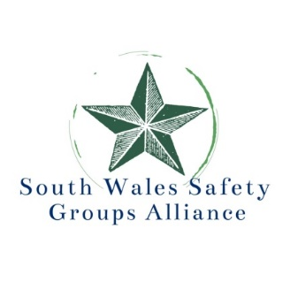
Annual Conference & Exhibition
PROTECTING PEOPLE AND PLACES
Fifty years after the Health and Safety at Work Act 1974
Wednesday 17th April 2024
Day’s Suite, Swansea.com Stadium (formally Liberty Stadium), Swansea SA1 2FA

8.30am - 9.30am Registration, refreshments and making contacts in exhibition

9.30am – 9.40am Welcome and chair’s opening remarks
Harriet Topping, Head of Devolution Engagement and Policy Team, HSE

9.40am - 10.20am The significance of the ground breaking Health & Safety at Work Act 1974
Steve Pearce, Health and Safety Professional
10.20am – 11.00am Keynote Address
HSE Strategy priorities
Speaker from HSE tbc

11.00am - 11.30am Refreshments and making contacts in exhibition

11.30am – 12.10am IOSH Activate 2028 - towards safe, healthy & socially just, ways of working
Stuart Hughes, President, IOSH

12.10pm - 12.50pm Achieving Net Zero - A sustainable future
Louise Hosking, Executive Director of Environmental Health,
Chartered Institute of Environmental Health

12.50pm – 1.00pm Question and Answer Session

1.00pm – 2.00pm Lunch and making contacts in exhibition

2.00pm - 2.40pm Impacts of the Adoption of Artificial Intelligence for Safety Applications
Gash Bhullar, MD, Control 2K Ltd

2.40pm - 3.20pm Improving Wellbeing and Mental Health in the Workplace
Karen Rogers, Health & Safety Manager and Madeleine Harris, Wellbeing Champion,
Dwr Cymru/Welsh Water

3.20pm – 3.40pm Question and Answer Forum

3.40pm Close of conference

Chair : Harriet Topping, Head of Devolution Engagement and Policy Team, HSE

Delegate fee is £80 per delegate - which includes lunch and refreshments – car parking is free at the stadium - Booking via this link or https://www.eventbrite.co.uk/e/protecting-people-and-places-fifty-years-after-hswa1974-tickets-768628086297

Exhibition Stands cost £300 per stand –Exhibition Stand Information Pack link and Booking Form Link
If you do not have access to your organisation’s credit card, an invoice can be provided – please e mail South.Wales.sga@gmail.com to make that request.

