**HEALTH AND SAFETY THE WAY FORWARD**

**Wednesday 2nd April 2025**

**Ricoh Suite, Cardiff City Stadium, Leckwith Road, Cardiff CF11 8AZ**

|  |  |
| --- | --- |
| About the  South Wales Safety Groups Alliance | An alliance has been formed between IIRSM Wales Branch, IOSH South Wales Branch, The South Wales Construction Safety Group, Cardiff and South-East Wales Occupational Health and Safety Group and South and West Wales Occupational Safety Group.  The strategic aim of this alliance is to improve the Health, Safety and Wellbeing of all employees and others in South Wales. The Alliance, believe by adopting this united approach we are stronger and better able to communicate best practice and make a difference to the safety, health and wellbeing in workplaces and society in general. |
| About the  Annual Safety & Health Conference | South Wales Safety Groups Alliance is pleased to announce details of their 2025 conference and exhibition. This award winning, annual conference and exhibition is well established in the calendar of safety and health professionals in the area and has become a ‘must go to’ event. |

**Exhibition Stands**

**Fees: Excellent Value £350**

Exhibition stands at this event can only be booked by completion and return of the attached booking form (See attached). We are offering a limited number of exhibition stands and sponsorship opportunities to companies and organisations within the field of safety, health and wellbeing. Individuals, Companies and Organisations who wish to showcase their products or services.

There will be an allocated exhibition area for companies to choose a stand position. Exhibitors must be set up well before conference start and must remain in place until conference end.

A single exhibition stand space will comprise of a 2-metre x 0.5 metre covered trestle table (provided if required) plus a maximum of 1 metre space to one side (e.g., pop up banner) with chairs for up to two attendees per exhibition stand. The fee paid per stand includes lunch and refreshments for up to two attendees, plus entry into the conference. Full payment is required at the time of booking. A limited number of stands will be available with facility for electrical power although exhibitors will need to bring their own electrical extension leads (PAT compliant).

**Sponsorship**

Sponsorship of aspects of the conference are also invited.

£400 – Podium, £400 - Stage, £400 - Audio Visual Equipment, £200 - Prize Draw.

Other (please specify).

**Booking Procedure**

[Complete Booking Form](https://swwsafetygroup.co.uk/wp-content/uploads/2023/12/Exhibitors-Information-Pack-Alliance-Conference-Swansea-2024.docx)

Please refer to the booking form and event floor plan attached. Complete the booking form listing your preferred stand numbers then send the form back to Steve Bergiers, e-mail: [south.wales.sga@gmail.com](mailto:south.wales.sga@gmail.com)

(An invoice can be provided on request).

Cheques

Cheques are not accepted.

BACS

BACS payments to be made to ‘South Wales Safety Groups Alliance’ Bank **NatWest**, Sort Code **55-61-50**, Account No. **73679836.**

Pleasequote your **Business name** as the reference and BACS payment date.

The completed booking form is to be sent via e-mail to: [south.wales.sga@gmail.com](mailto:south.wales.sga@gmail.com)

By returning the completed booking form you are confirming that your organisation will attend and staff a stand at this event. The deadline for all bookings is **Monday 24th March 2025**, subject to availability. Any cancellation of exhibition stand booking received after **Monday** **24th March 2025** will be subject to a 25% charge, cancellations received prior to this date will be refunded fully.

**Booking Confirmation / Payment**

Your booking and stand allocation number will be confirmed when we have received the completed booking form together with full payment.

**Requirements for Exhibition Stand Holders**

* Exhibitors can access the Ricoh Suite (Level 3) via main reception.
* No exhibitors are permitted to provide food at the event.
* Any portable electrical equipment brought to the venue (e.g. extension / power cables) for use with the stand must display evidence of current portable electrical appliance inspection.
* Access to the venue is available from 7.00am on the day of the event for setting up.
* Taking down of stands not to be undertaken until after the end of the days programme.

**Cardiff City Stadium**

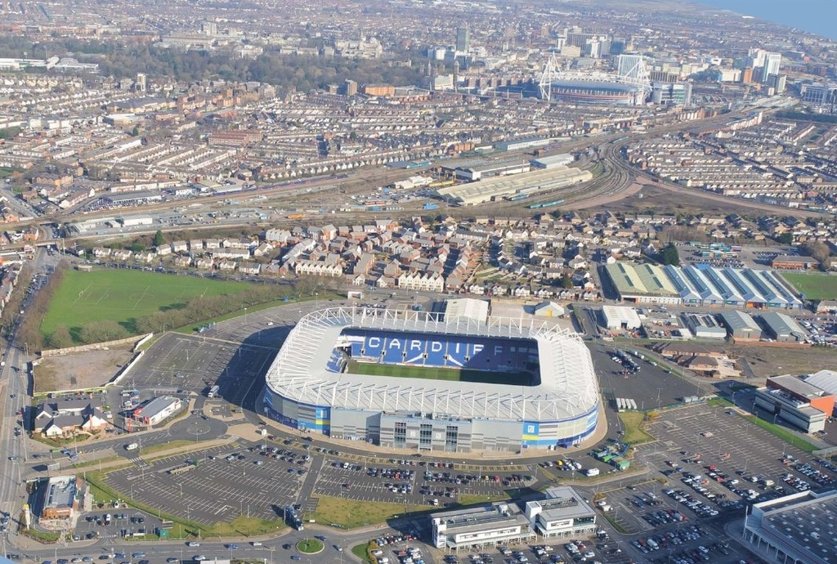

**Plan Layout**

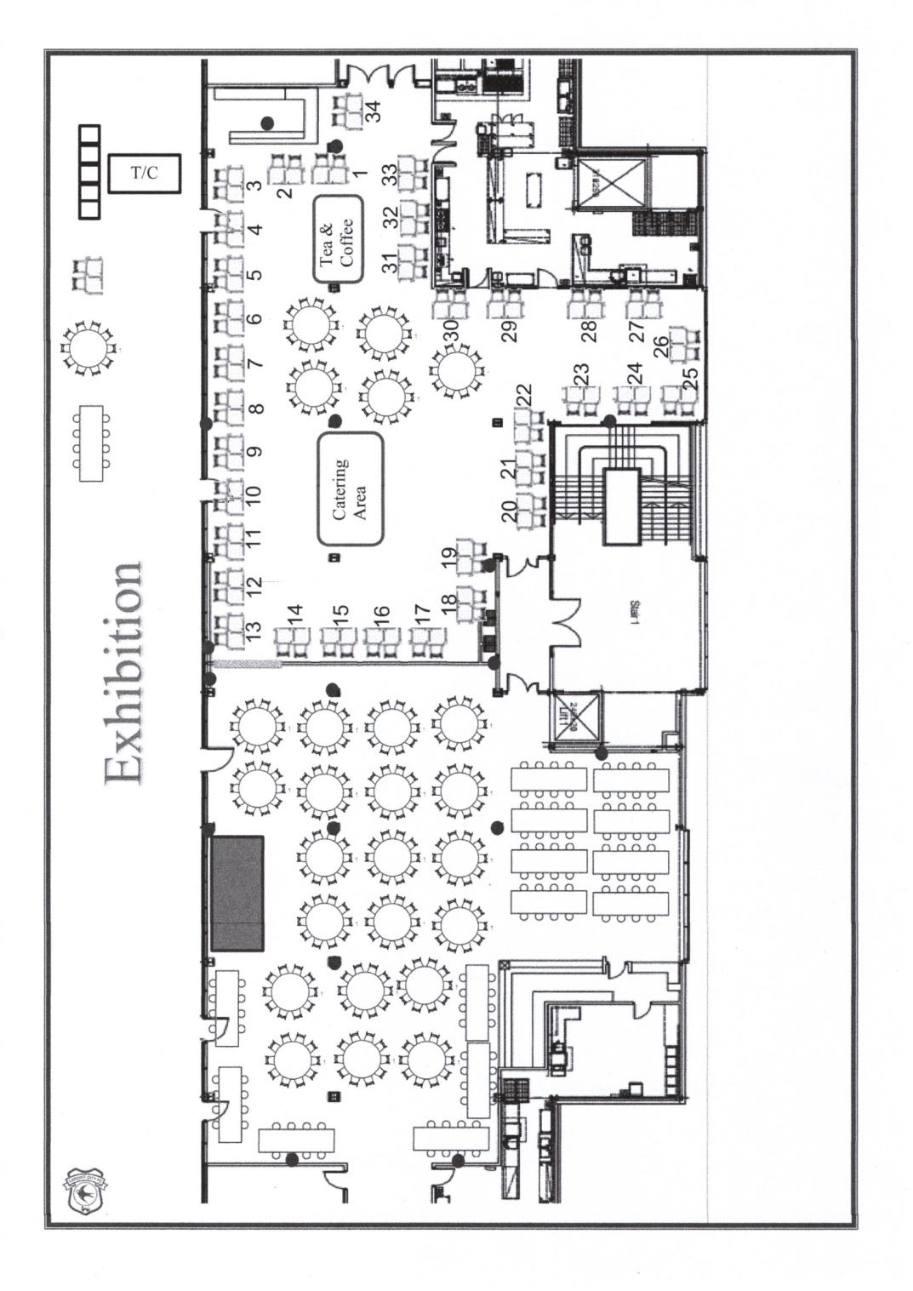

**Stands marked as blue have available**

**Cardiff City Stadium, Leckwith Road, Cardiff CF11 8AZ   
Main Telephone Number: 02920 643600**

**Directions**

Cardiff City Stadium is set in the Leckwith area of Cardiff, the Stadium is easily accessible.

**By Car**

If you're travelling to the Stadium by car, access to us from the M4 is easy. Leave the **M4 at junction 33** and take the **A4232** towards Cardiff/Barry. Exit the A4232 on to the **B4267** turn-off, signposted towards Cardiff City Stadium. You'll see us on the horizon as you approach the turn-off!

Follow the slip-road off the B4267 and take the first left at the roundabout - the Stadium will be on your right hand side. Turn right at the second set of traffic lights and follow the conference centre signage for your parking.

**Car Parking**  
There is a large, free car park at the stadium.