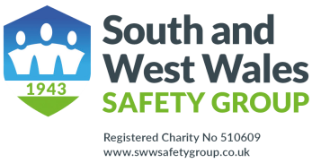

Application for Annual Membership

|  |  |  |  |
| --- | --- | --- | --- |
| Individual Member | Organisations with 20 or less employees | Organisations with 21 to 250 employees and registered charities | Organisations with more than 250 employees |
| £10 | £25 | £60 | £100 |

|  |  |
| --- | --- |
| Name of Organisation |  |
| Number of Employees |  |
| Type of organisation/industry |  |
| Address and Company telephone number |  |
| Company Website |  |
| Name of main contact e mail and job title |  |
| Mobile number of main contact |  |
| Payment method please state BACS or cheque |  |
| Please state any offer code |  |

Please send a cheque for the appropriate amount made payable to

South and West Wales Safety Group or payment by BACS to:

Bank: Barclays, Kingsway Swansea Branch Sort Code 20-84-41 Account No: 50853569

If paying by BACS e mail this form to [sheree.waldman@sicltd.com](mailto:sheree.waldman@sicltd.com)

**Or post with cheque to Sheree Waldman, 1078 Carmarthen Road, Swansea SA5 4AL**

It would be appreciated if a copy of this form could be e mailed to Ann Jones, [annjonessafety@aol.com](mailto:annjonessafety@aol.com)

Safer Together