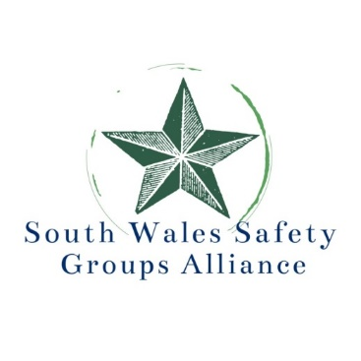

**Annual Conference & Exhibition**

**HEALTH AND SAFETY - THE WAY FORWARD**

**Wednesday 2nd April 2025**

**Ricoh Suite, Cardiff City Stadium, Leckwith Road, Cardiff CF11 8AZ**

**Delegate fee £90 – Booking via** [**Eventbrite**](https://www.eventbrite.co.uk/e/health-and-safety-the-way-forward-tickets-1152473241489)

**https://www.eventbrite.co.uk/e/health-and-safety-the-way-forward-tickets-1152473241489**

**South Wales Safety Groups Alliance** is a partnership of: **South Wales Branch IOSH, Wales Branch IIRSM, South Wales Construction Safety Group, Cardiff & South East Wales Occupational Health & Safety Group and South & West Wales Safety Group** with a strategic aim to improve safety, health and wellbeing of all employees and others in the area.

This year’s conference and exhibition will be part of the celebrations to mark the fiftieth anniversary of the formation of the HSE in January 1975. It is in line with the HSE vision of **Protecting People and Places** and their strategy which focuses on tackling both new and traditional risk, responding to future challenges and the changing landscape of work.

We start with looking at the New Building Act and plans for its enforcement in Wales. Followed by a talk on ‘up to the minute’ methods of dealing with the age old risks of working at height.

Work related ill-health is still increasing with the most commonly reported causes being stress, depression and anxiety. Our speaker will suggest ways to dealing with these issues. PPE is next on the agenda with a review of the regulations and regulatory landscape. The afternoon session sees us discussing both the novel and the old concerns – use of drones and driving at work.

We have attracted excellent speakers who are renowned experts in their field, who will inform and entertain. This conference is not to be missed!

Visit our vibrant exhibition, showcasing safety solutions from local and national businesses. It is a great opportunity to network with our speakers, exhibitors, and fellow delegates.

Don't miss the chance to win a thrilling supercar circuit drive in our exciting prize draw to conclude the day! Secure your spot now for a unique blend of history, innovation, and networking at the **South Wales Safety Groups Alliance conference and exhibition** – where it's not just an event but a catalyst for the future of workplace safety!

*CELEBRATING 50 YEARS OF THE HEALTH AND SAFETY EXECUTIVE*

*With a set of shared objectives, HSE helps to keep Great Britain one of the safest and best places to live and work. Bringing people and organisations together, sharing knowledge, expertise and data, they make a real impact on reducing death, ill health and injury.*

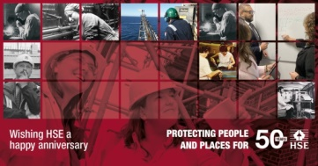

**All for the excellent value of £90 per delegate Booking via** [**this link**](https://www.eventbrite.co.uk/e/health-and-safety-the-way-forward-tickets-1152473241489) **or**

**https://www.eventbrite.co.uk/e/health-and-safety-the-way-forward-tickets-1152473241489**

If you do **not** have access to your organisation’s credit card, an invoice can be provided – please e mail [South.Wales.sga@gmail.com](mailto:South.Wales.sga@gmail.com) to make that request. For any inquiries or additional information, please contact Ann Jones, South Wales Safety Groups Alliance: mob 07870 316475 email [South.Wales.sga@gmail.com](mailto:South.Wales.sga@gmail.com)

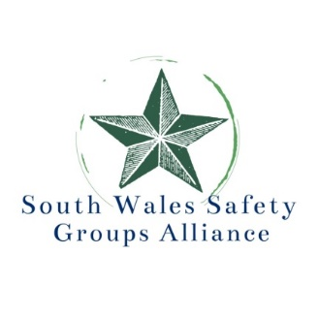

**Annual Conference & Exhibition**

**HEALTH AND SAFETY - THE WAY FORWARD**

**Wednesday 2nd April 2025**

**Ricoh Suite, Cardiff City Stadium, Leckwith Road, Cardiff CF11 8AZ**

**8.30am - 9.30am** *Registration, refreshments and making contacts in exhibition*

**9.30am – 9.40am Welcome and chair’s opening remarks**

***Scott McKinnon, South Wales Safety Groups Alliance***

**9.40am - 10.20am The Building Safety Act in Wales**

***Mark Tambini, Head of Building Regulations Policy, Welsh Government***



**10.20am – 11.00am The sharp edge of height safety**

***Jamie Appleton, Technical Business Development Executive-Height Safety, JSP Ltd***

**11.00am - 11.30am** *Refreshments and making contacts in exhibition*

**11.30am – 12.10am Future Role of Occupational Health**

***Dr Richard Skinner, Insight Workplace Health Ltd***

**12.10pm - 12.50pm Update on PPE Regulations and a review of the regulatory landscape *. Alan Murray, CEO, British Safety Industry Federation & President Safety Groups UK***

**12.50pm – 1.00pm Question and Answer Session**

**1.00pm – 2.00pm** *Lunch and making contacts in exhibition*

**2.00pm - 2.40pm Remote Survey Operations in Inaccessible and Hazardous Areas using drones**

***Mark Hudson, Managing Director, Geoterra***

**2.40pm - 3.20pm Driver safety and how it can influence businesses and individuals to drive with awareness  *. Sergeant Dave Hawksworth, Specialist Operations Department, Dyfed Powys Police***

**3.20pm – 3.40pm Question and Answer Forum**

**3.40pm Prize draw for SUPERCAR DRIVE and close of conference**

**Chair : *Scott McKinnon, South Wales Safety Groups Alliance***

**Delegate fee** is £90 per delegate - which includes lunch and refreshments – car parking is free at the stadium **Booking via** [**this link**](https://www.eventbrite.co.uk/e/health-and-safety-the-way-forward-tickets-1152473241489) **or**

[**https://www.eventbrite.co.uk/e/health-and-safety-the-way-forward-tickets-1152473241489**](https://www.eventbrite.co.uk/e/health-and-safety-the-way-forward-tickets-1152473241489)

If you do **not** have access to your organisation’s credit card, an invoice can be provided – please e mail [South.Wales.sga@gmail.com](mailto:South.Wales.sga@gmail.com) to make that request.

**Exhibition Stands** cost £350 per stand –[Exhibition Information Pack Link](https://view.officeapps.live.com/op/view.aspx?src=https%3A%2F%2Fswwsafetygroup.co.uk%2Fwp-content%2Fuploads%2F2024%2F11%2FExhibitors-Information-Pack-Alliance-Conference-Swansea-2025.docx&wdOrigin=BROWSELINK)  and [Booking Form Link](https://view.officeapps.live.com/op/view.aspx?src=https%3A%2F%2Fswwsafetygroup.co.uk%2Fwp-content%2Fuploads%2F2024%2F11%2FExhibition-Stand-BOOKING-FORM-Swansea-2025.docx&wdOrigin=BROWSELINK)