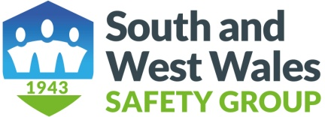
APPLICATION FOR MEMBERSHIP BY AN INDIVIDUAL

Name…………………………………………………………………………………

Address……………………………………………………………………………….

………………………………………………………………………………………..

…………………………………………………………………………………………

Telephone No………..………………………………………………………………...

E mail Address………………………………………………………………………….

Payment BACS or Cheque............................................................................................

Please State any offer code............................................................................................
Membership Fee is £10 for individual members
If returning by e mail please send form to:
sheree.waldman@sicltd.com and annjonessafety@aol.com

BACS is the preferred method, unfortunately we cannot take credit or debit card payments.
Bank: Barclays, Swansea Branch.
Sort Code 20-84-41 Account No: 50853569
If paying by cheque it should made payable to South and West Wales Safety Group with your name on the back of the cheque and sent with copy of the form to our treasure:

Sheree Waldman, 1078 Carmarthen Road, Swansea SA5 4AL
Safer Together

