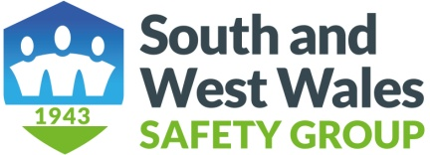

APPLICATION FOR MEMBERSHIP BY AN ORGANISATION

Name of Contact……………………………………………………………………...................................

Position………………………………………………………………………………..................

Organisation……………………………………………………………………………...............

Address………………………………………………………………………………...................

………………………………………………………………………………………....................

Telephone No of contact……………………………....................................................................

E mail Address of contact…………………………….................................................................

Number of Employees…………………………………………………………………...............

Type of Organisation……….…………………………………………………………...............

Website………………………………………………………………………………….............

Please state payment method BACS or cheque............................................................................

Please state any offer code..............................................................................................................

BACS is the preferred payment method. Unfortunately we cannot take credit or debit card payments.
Bank: Barclays, Swansea Branch
Sort Code 20-84-41
Account No: 50853569

Membership Fees are:
£25 for organisations with 20 or fewer employees
£60 for organisations with between 21 and 250 employees and charities
£100 for organisations with more than 250 employees

If returning by e mail please send form to:

sheree.waldman@sicltd.com and annjonessafety@aol.com

If paying by cheque it should made payable to South and West Wales Safety Group with your company name on the back of the cheque and sent with copy of the form to our treasure:

Sheree Waldman, 1078 Carmarthen Road, Swansea SA5 4AL

Safer Together

