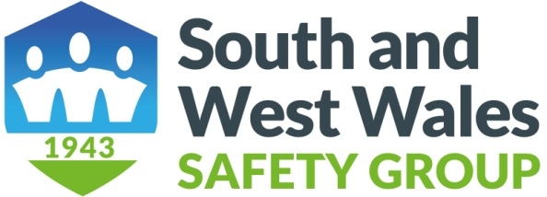

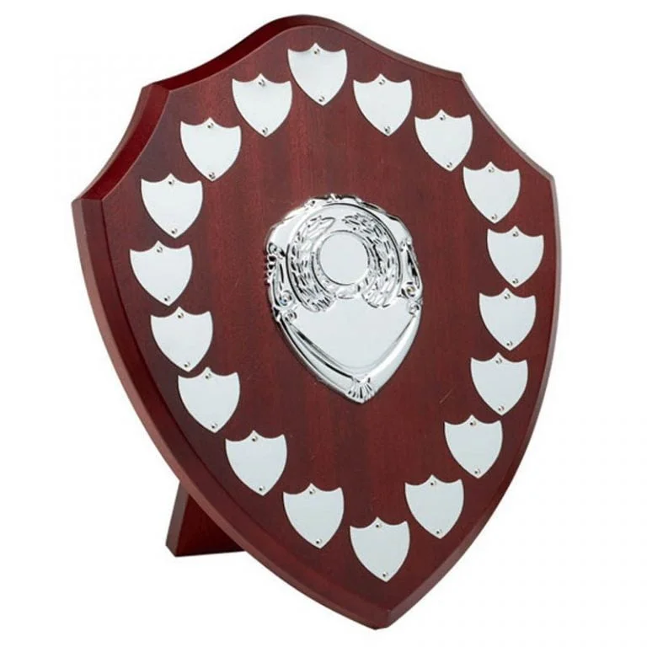

**Annual Safety Awards 2024**

This year there will be three safety shields being awarded:

* Micro shield - for organisations with up to 20 employees
* SME shield - for organisations with 21 to 250 employees
* Large shield - for organisations with over 250 employees

**APPLICATION FORM**

Name of contact……………………………………………………………….

Organisation……………………………………………………………………

Address………………………………………………………………………….

…………………………………………………………………………………..

Tel………………………………..Mob…………………………………………..

Email…………………………………………………………………………….

Number of Employees………………………………………………………...

Please provide a summary of your activities in 2024 undertaken in each of the following categories in the space below which will expand with content:-

* Safety Projects and Initiatives:
* Safety Training:
* Occupational Health and Wellbeing:
* Employee Engagement:
* Community Engagement:

Applications to be sent to Rex Jensen e mail [rexj27@yahoo.co.uk](mailto:rexj27@yahoo.co.uk) by Thursday 15th May 2025 having re-named your form to identify your organisation. You should receive an acknowledgement by email within two working days. If no acknowledgement is received, please contact Rex on mobile no 07502 098804

*Judgement of the awards will be by a small panel of South and West Wales Safety Group’s committee members. We rely upon the honesty and integrity of our members when making their application. We will* ***not*** *visit your**premises or audit your application. We* ***do not*** *require large amounts of information, photos or copies of your documentation, but brief supporting information can be attached to your application and/or reference to e-documents and websites – two or three pages A4 will suffice.*

The shields will be presented to the award winners at our Alec Blackburn seminar on 25th June and the winners will be invited to speak about their application at the launch of our 2025-2026 programme at 2pm Wednesday 24th September 2025.

Good luck with your application.